**Full Stack Development with MERN**

**Frontend Development Report**

|  |  |
| --- | --- |
| Date | 13-07-2024 |
| Team ID | SWTID1719929609 |
| Project Name | BOOK NEST |
| Maximum Marks | 10 |

**Project Title:** BOOK NEST

Date: 13-07-2024

Prepared by: Team BookNest

**Objective**

The objective of this report is to document the frontend development progress and key aspects of the user interface implementation for the Book Nest project.

**Technologies Used**

* **Frontend Framework:** React.js
* **State Management :** No external state management
* **UI Framework/Libraries:** Tail Wind
* **API Libraries:** Axios

**Project Structure**

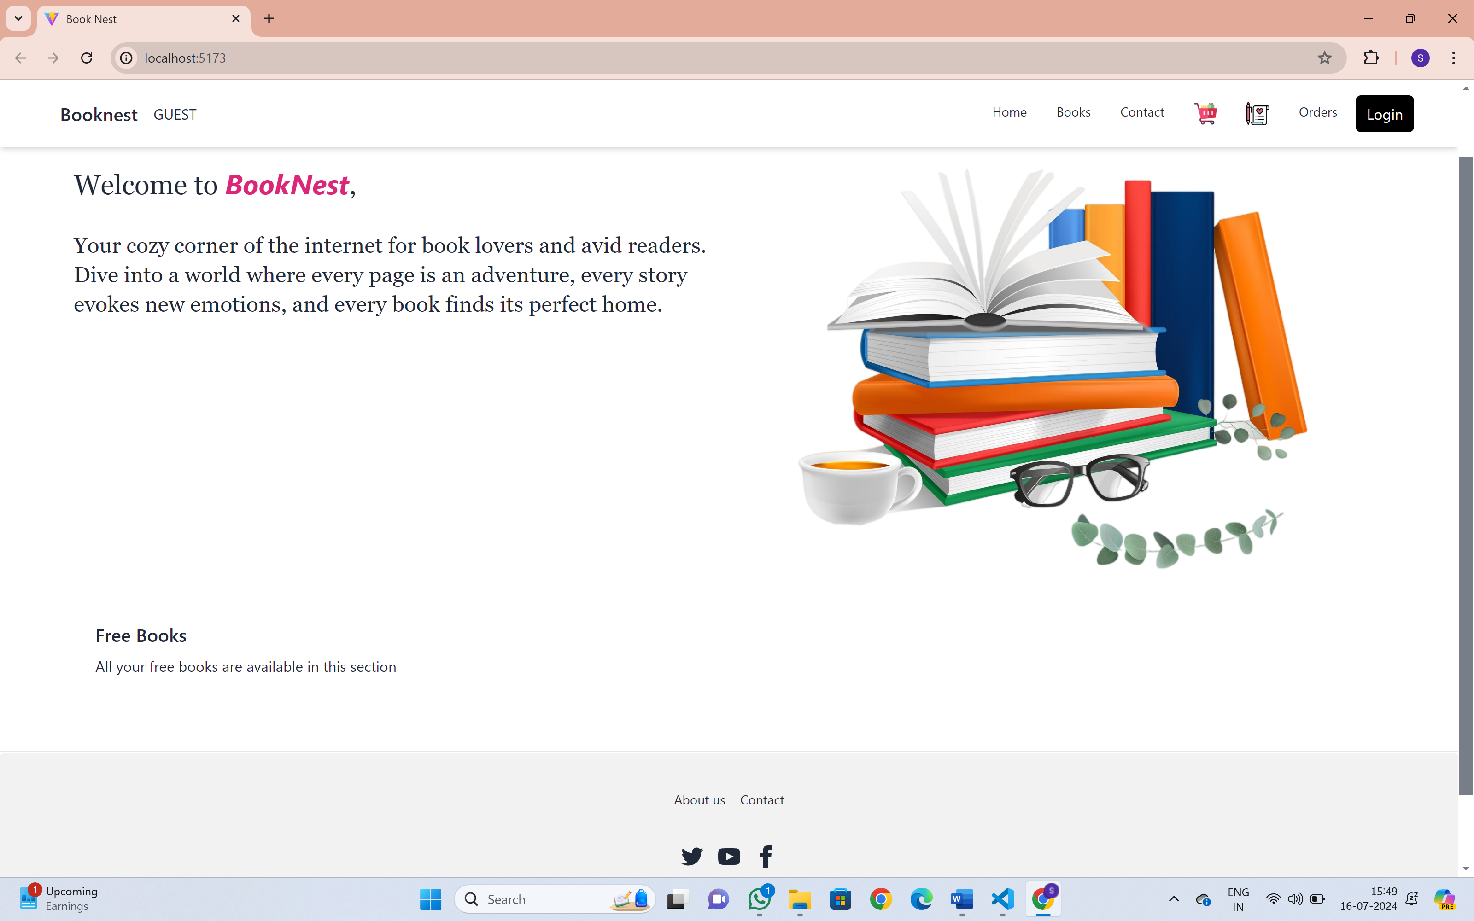

* **BookNest Logo:** The website logo "BookNest" is displayed prominently at the top-left corner. This is part of the branding and helps users identify the site.
* **Guest Label:** The label "GUEST" indicates that the user is currently not logged in.
* **Navigation Menu:**
  + **Home:** A link to the homepage.
  + **Books:** A link to the books section where users can browse and purchase books.
  + **Contact:** A link to the contact page where users can get in touch with the website's support or management team.
  + **Shopping Cart Icon:** Represents the user's shopping cart where selected books for purchase are stored.
  + **Orders Icon:** A link to view the user's past and current orders.
  + **Login Button:** A button for users,sellers and admin to log in to their accounts.

**Key Components**

**1.App.jsx :** Responsible for routing and main application layout.

**2./components:** Contains reusable UI components used across the application.

3./**Admin**: Contains admin related pages like adminseller,adminusers,admin header,footer,navbar.

4.**/seller**: contains sellerbooks,seller home and its header,footer and navbar

5.**/UserOrders** : contains orders placed by users

6**./cart**: Books are stored here before placing order

7.**/home**: contains home page

8.**/assets** : contains pictures displaying on cart,wishlist

**Routing**

Routing is managed using React Router. Here are the main routes:

* **/ - Home page**
* **/course-** Courses
* **/usersignup –** UserSignUp form
* **/contact –** Contact form
* **/sellerlogin –** Sellerlogin form
* **/sellersignup -** seller signup form
* **/adminlogin –** admin login form
* **/Adminhome –** admin home
* **/cart -** place where books are added before ordering
* **/addbook –** It add books in seller page
* **/Mybook –** The books which are added by seller
* **/userlogin –** User login form
* **/wishlist –** Books which are wishlisted
* **/userorders –** orders placed by users
* **/placeorder –** To place the order
* **/adminusers –** Admin can see the users
* **/adminsellers –** Admin can see the sellers
* **/adminorders –** Admin can see the orders
* **/sellerorders** - Seller can see the orders placed for their book

**Integration with Backend**

The frontend communicates with the backend APIs hosted on [localhost:8000]. Key endpoints include:

* **GET /api/data** - Retrieves data for display.
* **POST /api/user/login** - Handles user authentication.

**User Interface (UI) Design**

* The UI design follows principles of simplicity, minimalism, and user-centered design. It focuses on providing a clean and intuitive user experience with clear navigation and responsive layouts. Visual hierarchy and consistent styling enhance usability and readability throughout the application.
* Implemented using React and Tail Wind CSS.